
Cairns Golf Club
AGF Junior Girls Scholarship Program Nomination Form
Nominations for the program are open to girls aged 9 to 16 years.
Applicant information
Name

Date of Birth

Age

School

Grade/Year

Left or right handed

Contact Information
Parent/Guardian name

Relationship to applicant

Phone

Email

Golf information
How long has the applicant been playing golf

Recent tournament participation (if any)

Recent golf camps or coaching events (if any)

Recent golf lessons (if any) and coach name

Why is the applicant interested in being considered for the program?

Please provide details of any medical conditions, past or current injuries, disabilities, allergies or dietary requirements that we should be aware of (if any)

AGF Scholarship Merchandise


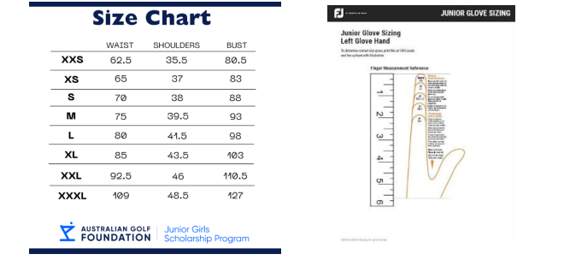
Shirt size
Junior Glove size
Parental/guardian consent
I hereby give consent for my child to be considered for the AGF Golf Academy program
Consent to photographs being used for social media content and advertising | Y | N

Parent/Guardian name

Signature

Date

Please email to golfmanager@cairnsgolfclub.com.au

